1. Summarize chapters from 12.4 to 12.8 in the text book.

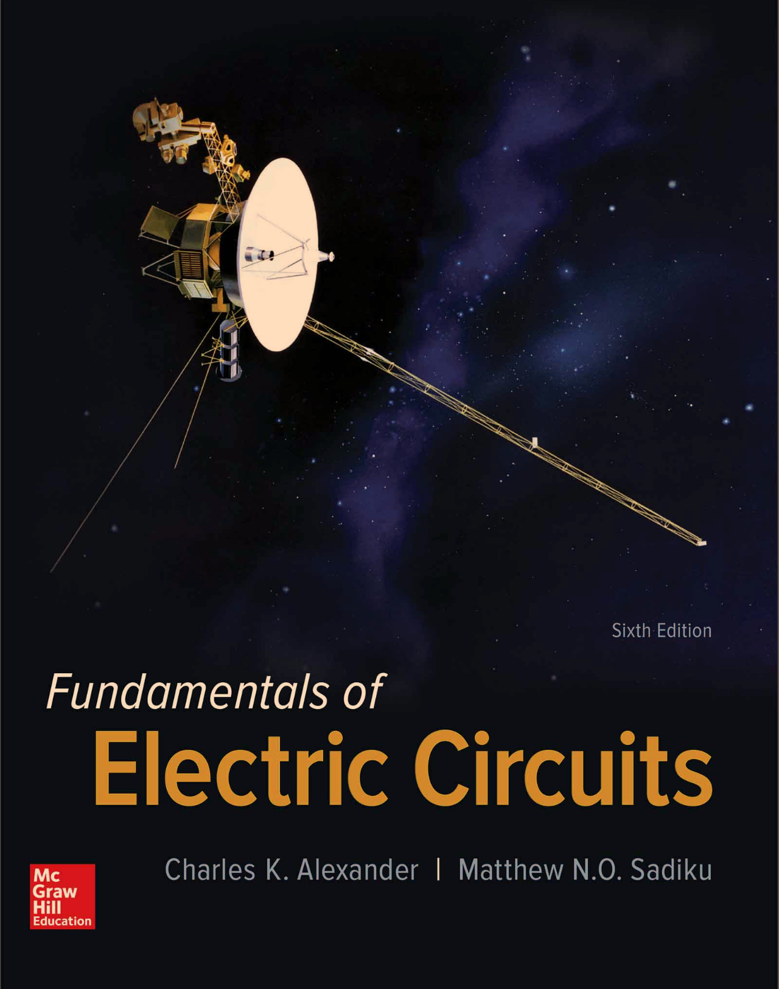

1. Please solve and write the answer to the examples (12.4, 12.5, 12.6, and 12.7) in handwriting. And take a picture for the solutions and attach the picture to the assignment file.